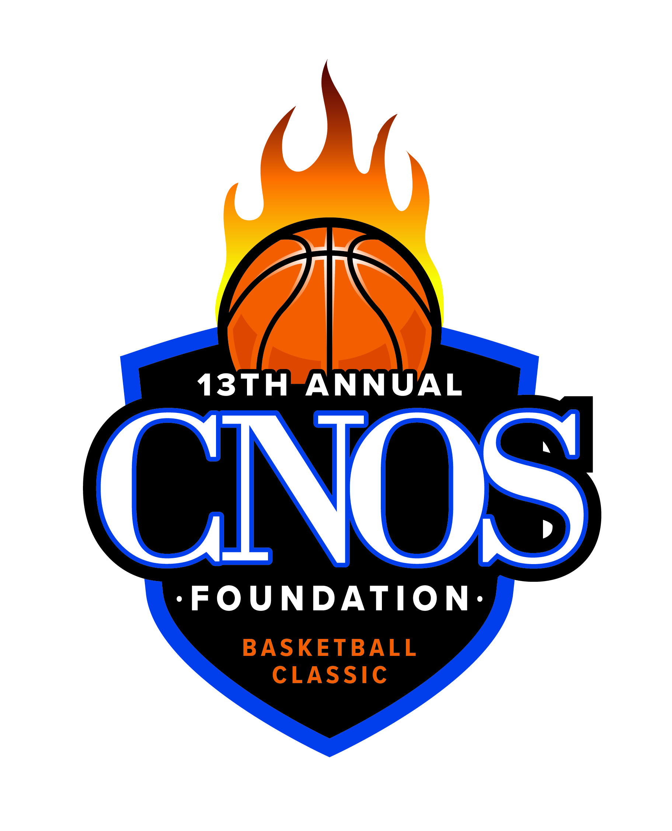

CNOS Foundation Basketball Classic
2019 Game Schedule
January 3 - 5, 2019

HOME TEAM VISITOR TEAM

Thursday, January 3
2:00 Sioux City East vs Siouxland Christian Girls

3:45 Sioux City North vs. Westwood Girls

5:30 Sioux City West vs. Denison Girls

7:15 Sioux City West vs. Denison Boys

9:00 Sioux City North vs. Dakota Valley Boys

Friday, January 4
2:00 OABCIG vs Wakefield Girls

3:45 West Sioux vs. Ponca Girls

5:30 South Sioux City vs. Ponca Boys

7:15 South Sioux City vs. Crofton Girls

9:00 Sioux City East vs. Boys

Saturday, January 5
8:00 Siouxland Christian vs. Allen Boys

9:45 Sergeant Bluff-Luton vs. Hinton Girls

11:30 Sergeant Bluff-Luton vs. Hinton Boys

1:15 Briar Cliff vs. Hastings Women

3:15 Briar Cliff vs. Hastings Men

5:15 Bishop Heelan vs. Omaha Skutt Girls

7:00 Bishop Heelan vs. Omaha Skutt Boys

8:45 Dakota Valley vs West Monona Girls

